Setup Blockchain (Hyperledger) network using docker images

1. Execute following commands to pull docker images required to run Blockchain locally
docker pull hyperledger/fabric-peer
docker pull hyperledger/fabric-membersrvc
docker pull hyperledger/fabric-baseimage:x86_64-0.2.1

2. Change tag of fabric-baseimage to latest.

This is required due to the issue https://jira.hyperledger.org/browse/FAB-300 as a
Workaround

docker tag <image-id> hyperledger/fabric-baseimage:latest

image-id : image id of baseimage can be found by running command “docker
images”

3. Create a directory
e.g mkdir blockchain-compose
cd blockchain-compose

4. Before running the docker-compose up we should have the following command need to be executed on docker if your docker version is greater than 1.12.3

export COMPOSE_CONVERT_WINDOWS_PATHS=1

5. Copy the below file in blockchain-compose directory

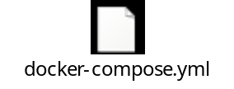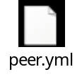

6. Run following command to start the Blockchain network with the images
(More information about docker compose can be found at :
https://docs.docker.com/compose/ )

docker-compose up

Make sure that to errors or failed messages displayed on the screen.

7. You can check running container by executing following command

docker ps –a

You should see 5 containers:

- peer _vp0_1
- peer _vp1_1
- peer _vp2_1
- peer _vp3_1
- peer _membersrvc0_1

PORT FORWARDING

Since port mentioned in docker-compose.yml files are not available in windows environment, we need to give the corresponding entry in virtual box for port forwarding.

Open virtual box→settings→networks→advance→Port forwarding.

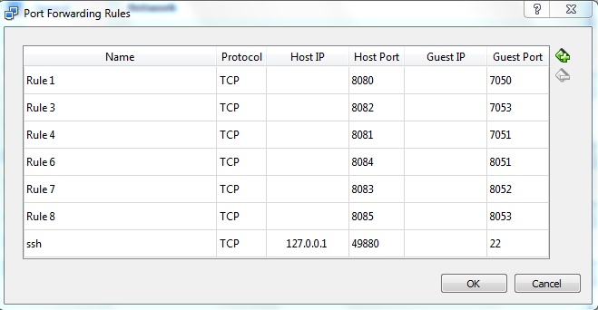

Through REST API

a. Use the IP address printed on Quickstart Docker Terminal (as mentioned in
Section A Step 9) as REST API Endpoint for REST API invocation.
b. Use any REST Client (e.g. REST Client for Firefox or Postman for Chrome)
c. Use the GET call below to make sure REST API endpoint is configured correctly.

http://<IP Address>:8080/network/peers
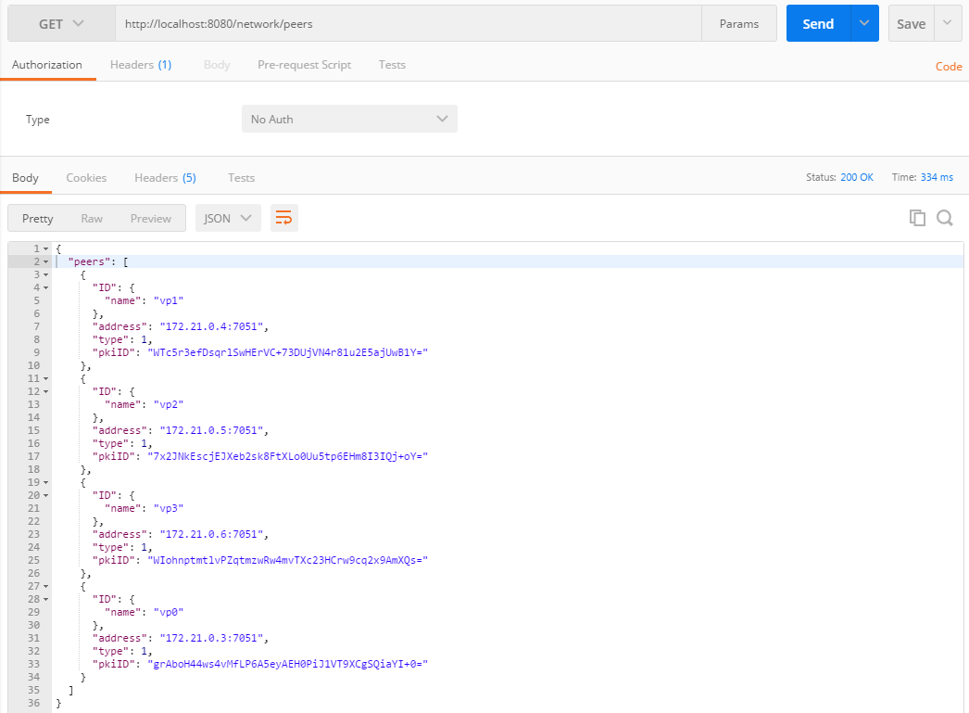

Use POST call to register the User

http://<IP Address>:8080/registrar

with Body as:
{
"enrollId":"test_user0",
"enrollSecret":"MS9qrN8hFjlE"
}

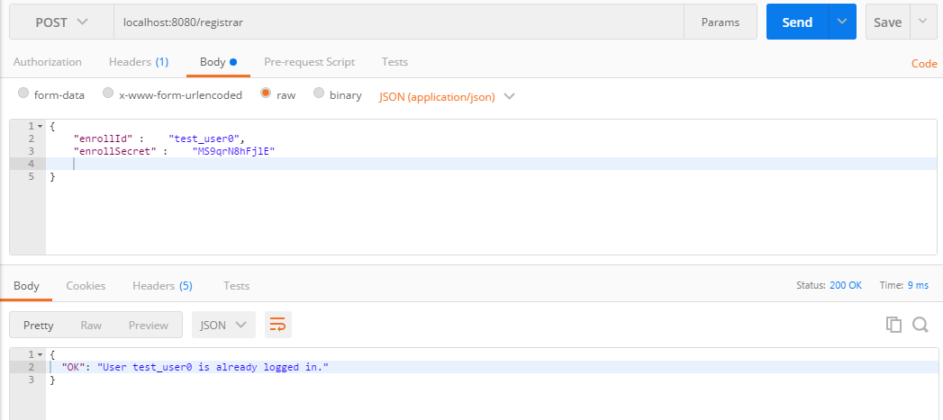

Deploy Chaincode with REST API

http://<IP Address>:8080/chaincode
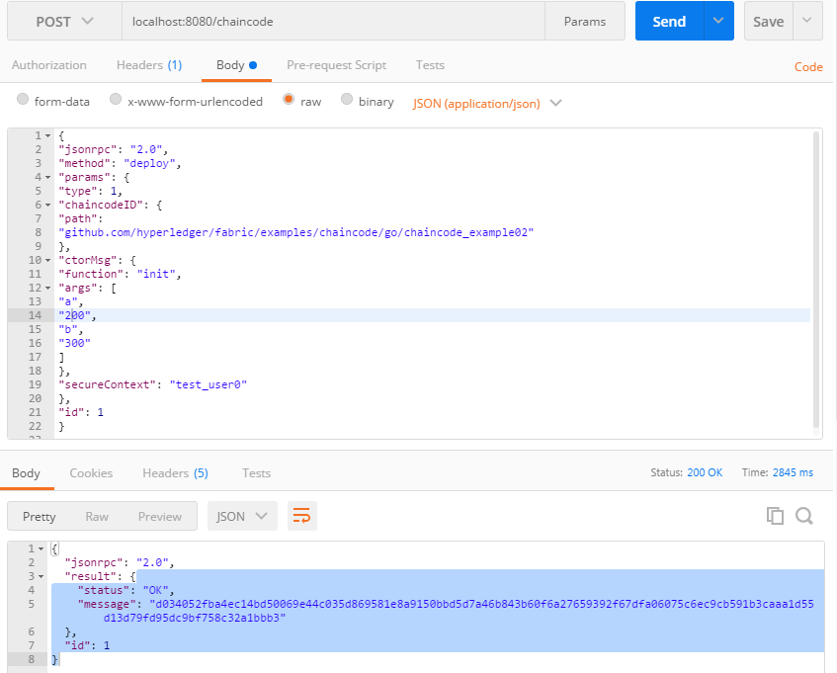
{
"jsonrpc": "2.0",
"method": "deploy",
"params": {
"type": 1,
"chaincodeID": {
"path":
"github.com/hyperledger/fabric/examples/chaincode/go/chaincode_example02"
},
"ctorMsg": {
"function": "init",
"args": [
"a",
"200",
"b",
"300"
]
},
"secureContext": "test_user0"
},
"id": 1
}

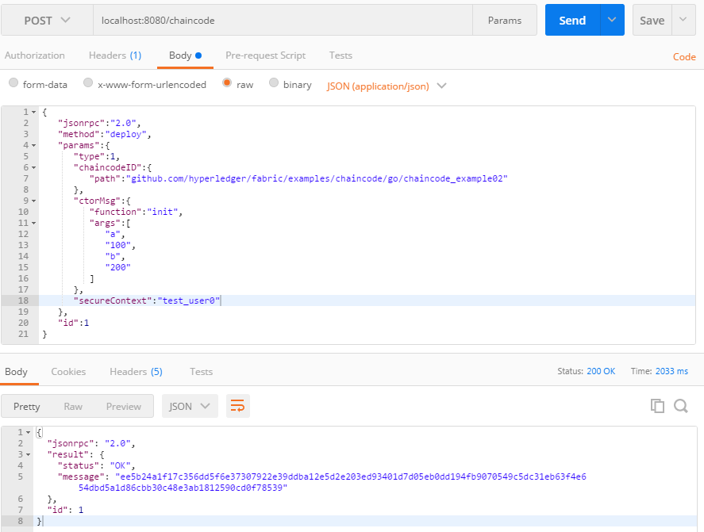

Note:→ please make sure after deploying the chaincode through the rest api as above we should see the 3 container after giving the below command.

docker ps –a

You should see 9 containers:

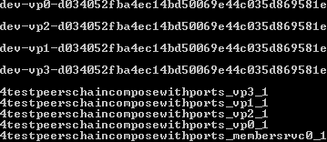

Invoke Chaincode with REST API

http://<IP Address>:8080/chaincode

{
"jsonrpc":"2.0",
"method":"invoke",
"params":{
"type":1,
"chaincodeID":{
"name": "ee5b24a1f17c356dd5f6e37307922e39ddba12e5d2e203ed93401d7d05eb0dd194fb9070549c5dc31eb63f4e654dbd5a1d86cbb30c48e3ab1812590cd0f78539"
},
"ctorMsg":{
"function":"invoke",
"args":[
"b",
"a",
"10"
]
},
"secureContext":"test_user0"
},
"id":1
}
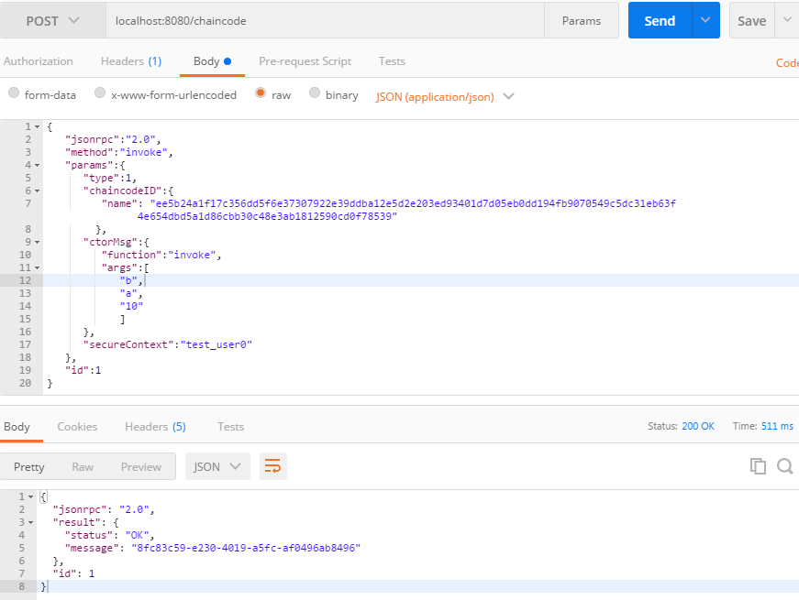

Query Chaincode with REST API

http://192.168.99.100:8080/chaincode

With Body as:
{
"jsonrpc": "2.0",
"method": "query",
"params": {
"type": 1,
"chaincodeID": {
"name":
"ee5b24a1f17c356dd5f6e37307922e39ddba12e5d2e203ed93401d7d05eb0dd19
4fb9070549c5dc31eb63f4e654dbd5a1d86cbb30c48e3ab1812590cd0f78539"
},
"ctorMsg": {
"function": "query",
"args": [
"b"
]
},
"secureContext": "test_user0"
},
"id": 2
}

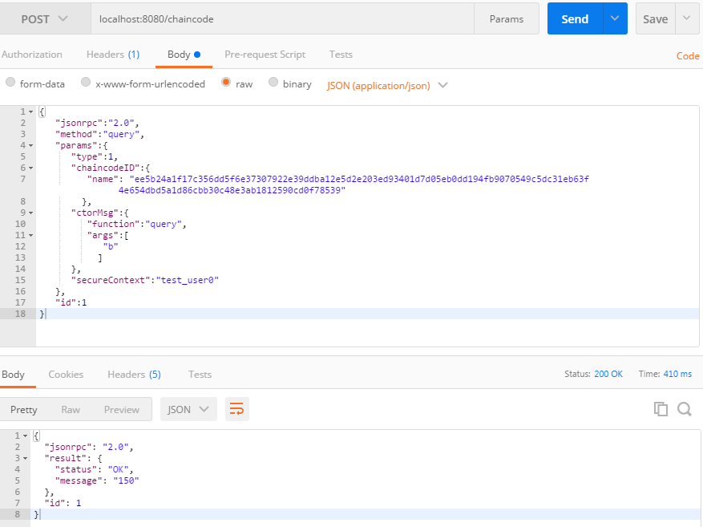

8. Now Register another User on different port which is mapped to different peer (Other than ‘test_user9’) and follow the below steps:

Use POST call to register the User

http://<IP Address>:8080/registrar

With Body as:
{
"enrollId":"test_user9",
"enrollSecret":"H80SiB5ODKKQ"
}

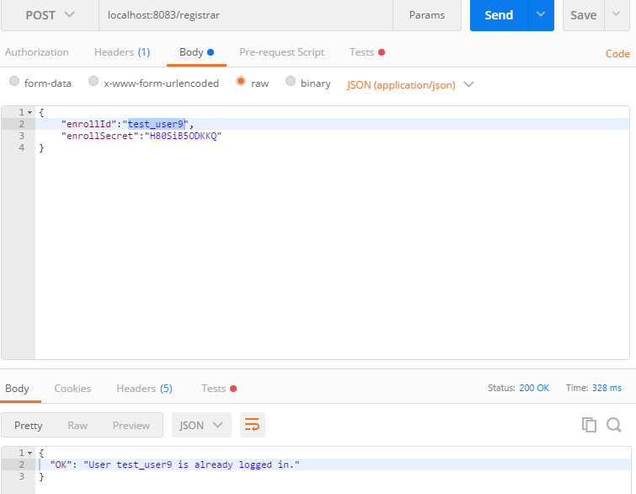

Query Chaincode with REST API

http://192.168.99.100:8080/chaincode

With Body as:
{
"jsonrpc": "2.0",
"method": "query",
"params": {
"type": 1,
"chaincodeID": {
"name":
"ee5b24a1f17c356dd5f6e37307922e39ddba12e5d2e203ed93401d7d05eb0dd19
4fb9070549c5dc31eb63f4e654dbd5a1d86cbb30c48e3ab1812590cd0f78539"
},
"ctorMsg": {
"function": "query",
"args": [
"b"
]
},
"secureContext": "test_user9"
},
"id": 2
}
